# DECLARATION OF ORIGINALITY

We hereby certify that we are the sole author of this project and that neither any part of this work nor the whole work has been submitted for a degree to any other University or Institution.

We certify that, to the best of our knowledge, our work does not infringe upon anyone’s copyright nor violate any proprietary rights and that any ideas, techniques, quotation, or any other material from the work of other people included in our report or otherwise, are fully acknowledged in the accordance with the standard referencing practices.

We declare that this is a true copy our report, including any final revisions, as approved by our supervisor.

**Date: Yours Sincerely,**

**Place:** SuratVaibhav 206120316015

Arshil 206120316035

Sanket 206120316038

I

# ACKNOWLEDGEMENT

The success and final outcome of this project required a lot of guidance and assistance from many people and we are extremely privileged to have got this all along the completion of our project. All that we have done is only due to such supervision and assistance and we would not forget to thank them.

We heartily thank our internal project guide, **Mr. M.D. Patel(H.O.D. of I.T. Department),** for his guidance and suggestions during this project work. We would not forget to remember **Mr. J. R. Mahida** for his encouragement and more over for his timely support and guidance till the completion of our project work. The project would not have been successfully completed without continuous support, motivation extended by our colleagues and friends who were always with us whenever we needed.

We are thankful to and fortunate enough to get constant encouragement, support and guidance from all Teaching staffs of **I.T. Department** which helped us in successfully completing our project work.

Last but not least, thanks to **Dr. S & S. S. Ghandhy College of Engineering & Technology** for providing us the platform to represent the project.

# **Abstract**

BRTS E-Ticket Management System is a web based application that works within the centralized network the manual use of purchasing ticket is presently consume time by having to stay in queue and resolve the problem of change of many. For this reason an efficient system is to be proposed in this paper to ease the issue of purchasing ticket .The system allows passenger to purchase ticket from anywhere and anytime online, there is no need to go to BRTS station.

# **PROJECT PROFILE**

**Project Title:** BRTS E-Ticket Management System

**Project Type:** Web Application

**Front-End:** JavaScript, TypeScript, React.js, Next.js, Tailwind CSS

**Back-End:** Node.js, Express.js, JWT, SHA128

**Database:** MySQL

**Operating System:** Window XP, Android 4.0 (Minimum)

**Project Guide:** M.D. Patel

**Submitted By:** Arshil, Sanket, Vaibhav

**Submitted To:** Dr. S & S.S. Ghandhy College of Engineering & Technology,

Surat

Table of Contents

**Declaration of Originality** I

**Acknowledgement** II

**Abstract** II

**Project Profile** III

**Chapter-1 Introduction** ....................................................................................................... **1**

1.1 Project definition ......................................................................................................... 1

1.2 Scope of the project ..................................................................................................... 1

**Chapter-2 System Requirement study** ............................................................................... **2**

2.1 Problem of existing system .......................................................................................... 2

2.2 Requirement of proposed system.................................................................................. 2

2.3 Project Life Cycle Model ............................................................................................ 3

2.4 Software Requirement Specification ........................................................................... 5

**Chapter-3 System Design** .................................................................................................... **9**

3.1 E-R Diagram ............................................................................................................... 9

3.2 Data Flow Diagram ..................................................................................................... 9

3.2.1 Context Diagram ............................................................................................... 9

3.2.2 Level 1 DFD ................................................................................................... 10

3.3 Data Dictionary ......................................................................................................... 11

**Chapter-4 UML**  ................................................................................................................ **12**

4.1 Use case Diagram ..................................................................................................... 12

4.2 Activity Diagram ...................................................................................................... 13

**Future Scope**...................................................................................................................... **14**

**Conclusion** ......................................................................................................................... **15**

**Bibliography**  ..................................................................................................................... **16**

**Chapter 1 : Introduction**

The name of the project is BRTS E-ticket management system. Which is web application used to generate the BRTS bus ticket online in user’s device. The user have to select two destination one is current location and another is the destination place and the fare of the ticket is generated and it is credited from the app balance. User have to recharge and that balance is used to generate ticket. User can also cancel the ticket within the time limit. This portal provides features like transaction history and ticket history which gives more functionality and flexibility. The system is build for managing and computerizing the traditional database ticket booking and maintenance all customer’s details and ticket details.

**1.1 Definition**

The purpose of this project is to generate BRTS ticket on user mobile where user have to select current location and the destination. It have three different view which handles, first is admin view which handles and manages the system. The admin is technical person. Second is user view in which user can purchase ticket. Third is intermediate view in which ticket scanning and recharge can be done.

**1.2 Scope Of The Project**

This project is used to generate E-Ticket in mobile to overcome the maximum problems which are faces by the citizens who uses BRTS buses for daily travelling purpose. The online ticket is generated on user’s device and the history is saved. The system is build for managing and computerizing the traditional database ticket booking and to maintains all user’s details and ticket details. This portal provides transaction history and ticket history which gives more surety and authentication about processes. It also provides feature of ticket cancellation.

**Chapter 2 : System Requirement Study**

**2.1 Problem of Existing System**

* **Paper Wastage**

Even today the tickets are used in traditional way where a bus conductor gives the hard copy of the ticket to passengers which cause the paper wastage and resource wastage.

* **Time Wastage**

Selecting current location and destination and the ticket is being printed is kind of time consuming which cause a lot of trouble like some passengers don’t even take tickets , sometimes ticket are mistakenly selected of wrong destination etc..

* **More Manpower Needed**

The manually ticket checking is needed every time.

* **No tickets record / History keeping**

Sometimes a tickets gets toured or get lost by the passengers which cause a major problem of clashes between checker and passengers.

* **Corruptions**

Many times bus conductor don’t give the ticket to the passengers and sometimes passengers don’t buy tickets which cause corruptions and heavy loss to government.

**2.2 Requirements of Proposed System**

* **Simple and Minimal**

Our system contains minimal user interface which helps user to interact with portal and the good looking UI designing scheme attract user.

* **Wide Range Of City Station Supports**

It comes with many stations / BRTS stations which gains total advantage to user.

* **Top Up System**

Normally for payment user have to use secure transaction systems like UPI, Credit Card etc.. which cause security issues , to overcome that problem top up recharge systems is used , in which user have to recharge the app balance once and further used to generate ticket.

* **Custom Selection of Destination**

User have to select their current place and landing destination by themselves so there is no confusion or clash happen between user and conductor.

**2.3 Project Life Cycle Model**

This system underwent all the stages of system development lifecycle (SDLC). According to the nature of this system and the data collected, a waterfall methodology was used to develop this system. This methodology included the following stages: feasibility study, requirement analysis and specification design, coding, testing, integration then maintenance. Each phase required a different amount of effort and every phase had a well-defined starting and point.

Every phase had to be completed before beginning the next stage

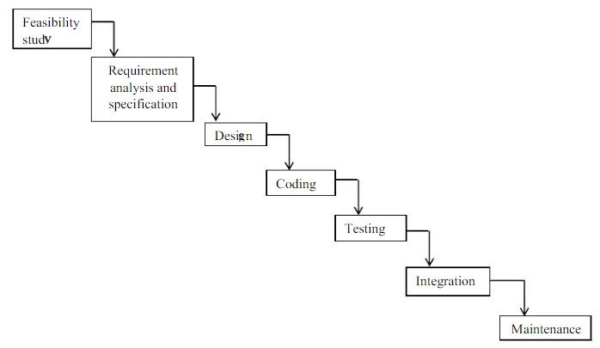

The waterfall methodology was worthwhile because this approach produced a complete qualitysystem and error-free system due to the fact that every phase had to be completed before the nextone began thus leaving no phase unattended.However, according to the data collected on the user requirements, there was a clearunderstanding of the user requirement hence no doubt on what was to be developed. Similarly,the approach was also less costly since there was no repeating of a process once completed andthus minimized wastage of resources as compared to other approaches such as the rapid prototyping methods.

 Data Collection Approaches

So as to collect data from Modern coast bus ticket booking system as well as its clients,appropriate methods of collecting data were needed. These techniques included the following:

* Observation

This involved the researcher going to the field of study, making direct watch on the way theorganization under study operates, identifying the possible drawbacks of the operating systemanalyzing the problems and developing a solution based on the observations made. Thistechnique was employed since it provides a first-hand information which is quite reliable andaccurate since the method provided a quick overview of the system. It is the most effectivetechnique.

* Interviews

This is a direct face to face conversation between the system analyst(interviewer) and the usersof the system. This was used where the respondents were few in order clarifying and verifyinggathered facts. This technique was important to use since some data could not be collected bydirect observation unless interviewed, hence it helped in enriching the data for quality processing.

* Questionnaires

A questionnaire refers to a set of questions prepared by the person collecting data in a paperwhich is issued to specific people who in turn respond to the questions privately without the presence of the interviewer. Once the respondent is through, he/she will issue the answers backto the person collecting the data. This technique was also important because some intervieweeswere not confident enough to respond to the question at the interview panel during the interviewand therefore a questionnaire best suited such people.

**2.4 Software Requirement Specifications**

* **General Specifications**

* + - * **User Characteristics**

Users have to log in if they have already registered themselves otherwise they have to create an account in order to use services provided by portal. They have to select destinations and generate ticket by themselves. They can check their balance and tickets history.

* + - * **System Characteristics**

This system can generate ticket whenever users select their destination then it generate ticket and calculate the fare mathematically. It provides facilities like reset password , editing profile , transaction history and ticket history.

* + - * **Software Requirements**

* + - * + Windows OS
        + Node.js
        + VS Code
        + My SQL
        + Apache Server
        + Web Browser
        + Git, Github Desktop
        + Postman

• **Hardware Requirements**

- Personal Computer (minimum 4 GB RAM , 128 GB SSD , Intel HD

520 , I3/I5 3rd Gen)

* + - * + Smart Phone
        + Stable Internet Connection

* **Functional Requirements**

* + - * **Registration**

Users have to register themselves by providing sign up details like Username , Phone number , E-Mail and have to set Password, in order to create new account.

* + - * **Login**

Existing users have to login in the system by using their username and password , if they forget password then they can change the password by authorizing themselves.

* + - * **Profile**

Users can see their profile information and they can modify their profile

* + - * **Ticket Booking**

Users have to select their current location and destination in order to purchase ticket. The fare of ticket is depending on the distance of locations.

* + - * **History**

User can see their transactions and ticket purchasing history.

* **Non Functional Requirements**

* + - * + Attractive GUI
        + Accessible Environment
        + Reliability
        + Availability
        + Security

* **Feasibility Study**

• **Overview**

A feasibility study aims to objectively and relationally uncovered strengths and weaknesses of an existing business or proposed venture, opportunities and threats present in the natural environment , the resources required to carry through, and ultimately prospects for success.

In its simplest term, the two criteria to judge feasibility are cost required and value to be attained.

• **Technical Feasibility**

This assessment is based on an outline of system requirements, to determine whether the company has the technical expertise to handle completion of the project. When writing a feasibility report, the following should be taken to consideration:

A brief description of the business to assess more possible factors which could affect the study. The part of the business being examined. The human and economic factor. The possible solution to the problem. The technical feasibility assessment is focused on gaining an understanding of the present technical resources of the organization.

* + - * **Operational Feasibility**

Operational feasibility is the measure of how well a proposed system solves the problems, and takes advantage of the opportunities identified during scope definition and how it satisfies the requirements identified in the requirements analysis phase of system development.

* + - * **Legal Feasibility**

Determines whether the proposed systems conflicts with legal requirements e.g. data processing systems must comply with the local data protection regulations and if the proposed venture is acceptable in accordance to the laws of the college.

* + - * **Financial Feasibility**

In case of a new project, financial viability can be judged on the following parameters: Total estimated cost of the project. Existing investment by the promoter in any other business.

Projected cash flow and probability. The financial viability of a project should provide the following information: Full details of the assets to be financed and how liquid those assets are, Rate of conversion of cash-liquidity.

* **Project Planning**

Software project planning is the collection of activities within software engineering. This chapter provides how to plan, track and estimate this website by managing various phases. It comprises of project development approach’s justification schedules, risk analysis, and cost and effort estimation.

• **Planning**

Project planning is part of project management, which relates to the use of schedules such as Gantt charts to plan and subsequently report progress within the project environment initially, the project scope is defined and the appropriate methods for completing the project are determined. Project planning is often used to organize different areas of a project, including project plans, workloads and the management of teams and individuals.

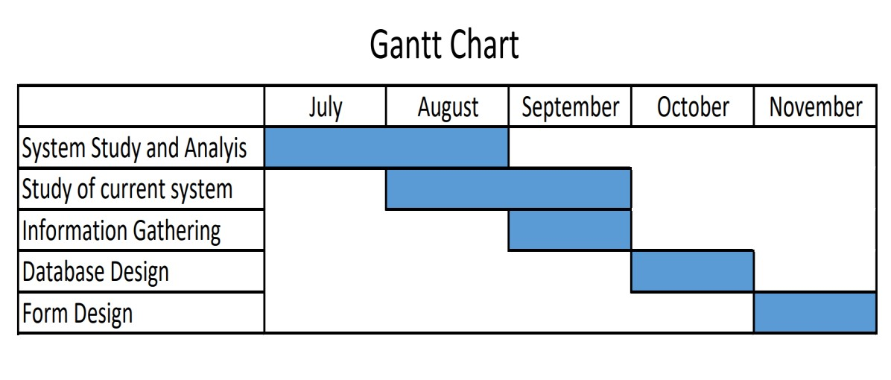

**Chapter 3 : System Design**

**3**

**.1**

**E**

**-**

**R Diagram**

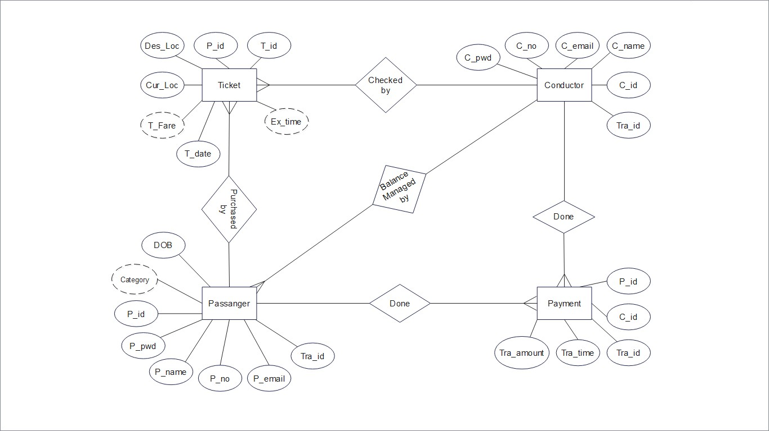

**3.2**

**Data Flow**

**Diagram**

**3.2.1**

**Context Level**

**Diagram**

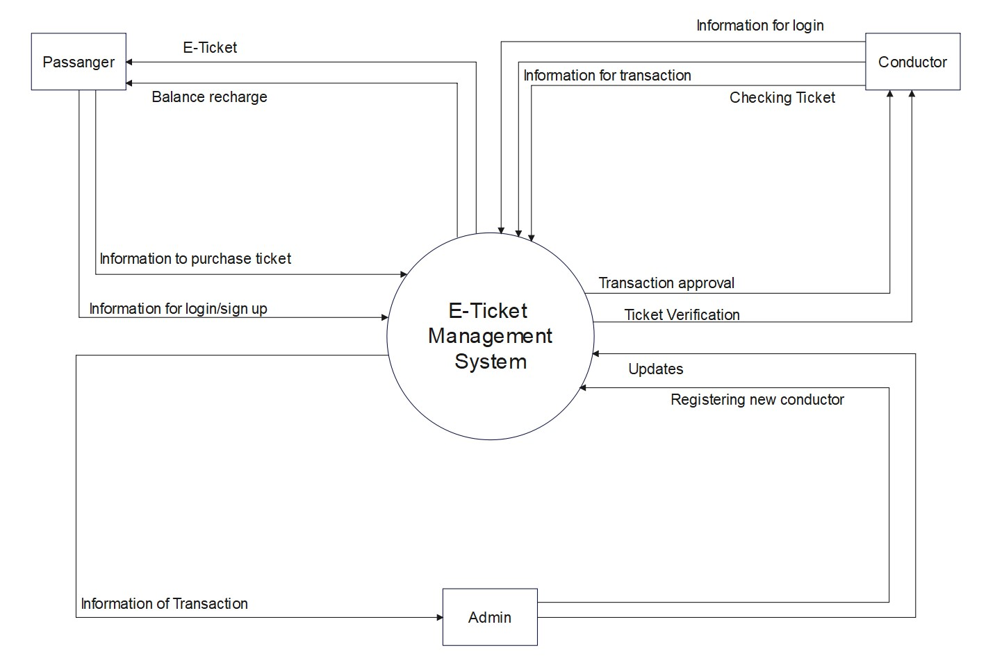

**3.2.2 Level-1 DFD**

**3.3**

**Data Dictionary**

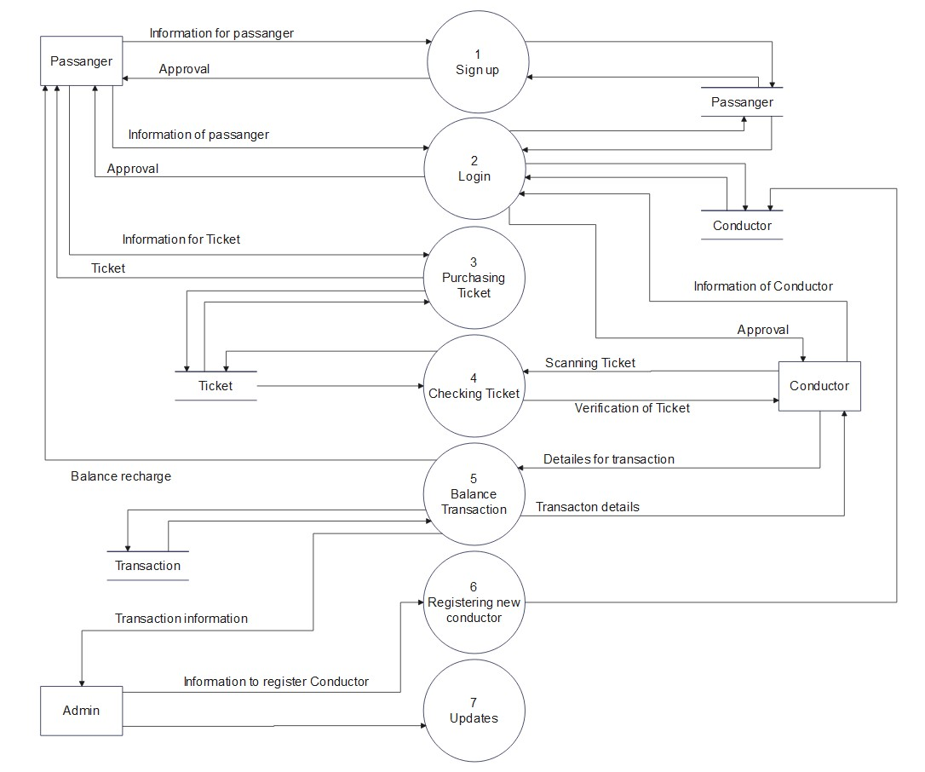

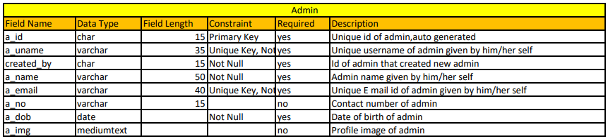

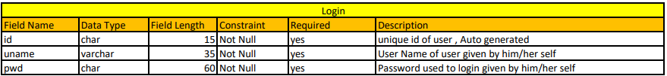

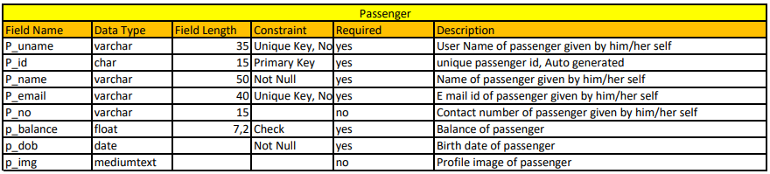

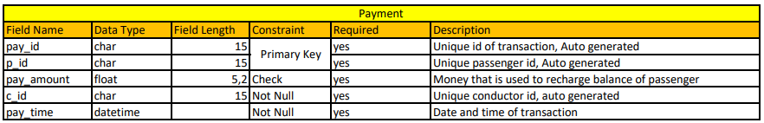

**Chapter 4 : System Design**

**4.1**

**Use**

**-**

**Case**

**Diagram**

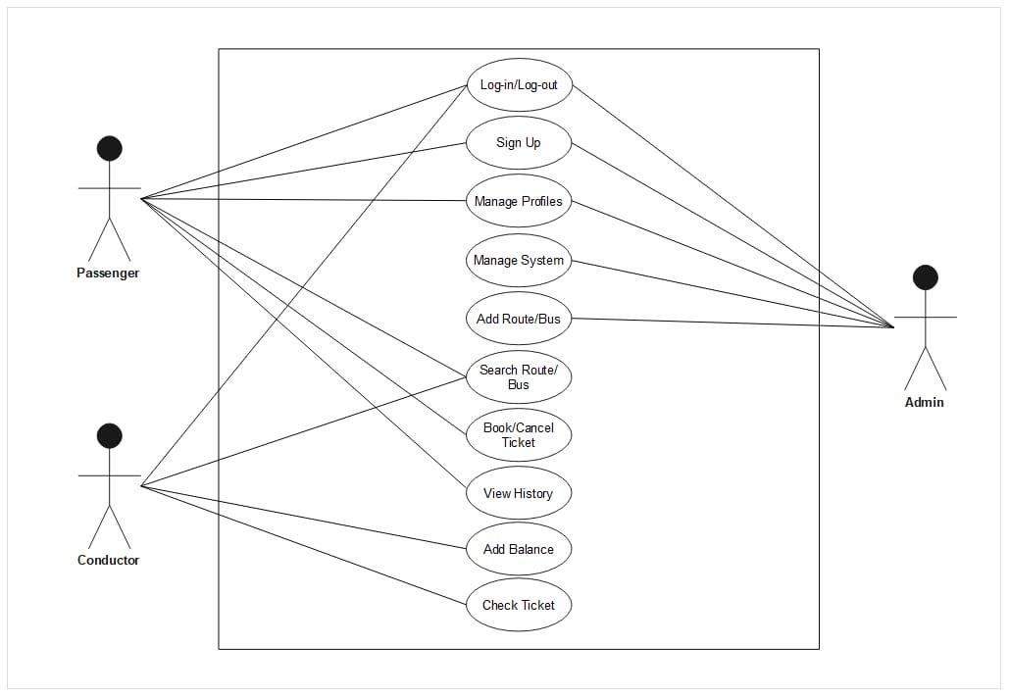

**4.2 Activity Diagram**

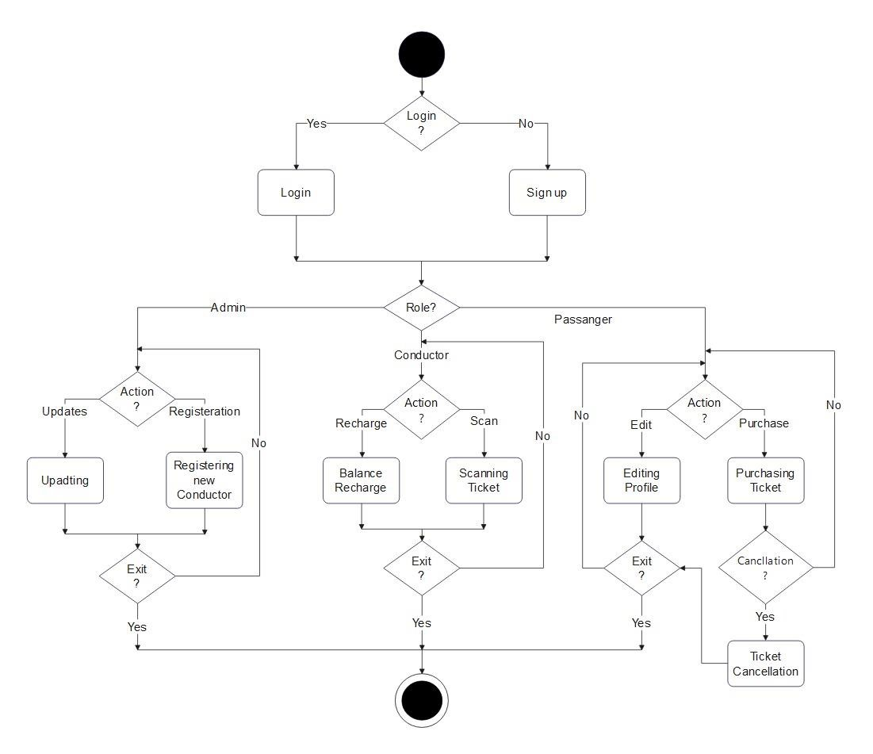

**Future Scope**

The Additional features for future can be following:

* + - * Bus Route Tracking:

System gives feature for users to see the live location of bus and the route of bus in the map.

* + - * Recharge through UPI:

System would develop feature like Payment through UPI, Debit-card, Credit-card etc.

* + - * Customer Feedback:

The system provide feedback feature to users for purpose of making system better.

* + - * Ticket Cancellation:

The system provide ticket cancellation to users.

**Conclusion**

Through this project we have learn all the concept which we have studied previously like Project Planning, Scheduling and Gathering data for better system etc. The purpose of this project was to identify effective strategies for dialing with repetitive motions identicals in individual with citizens problem.

**Bibliography**

* + - 1. GeeksforGeeks. 2020. *QuickSort - GeeksforGeeks*. [online] Available at: <https://www.geeksforgeeks.org/quick-sort/>
      2. En.wikipedia.org. 2020. *Linear search*. [online] Available at: <https://en.wikipedia.org/wiki/Linear_search>
      3. Academia.edu. 2020. *Direct search – academia.edu* [online] Available at:

<https://www.academia.edu/40839070/BUS_TICKET_RESERVATION_SYSTEM>